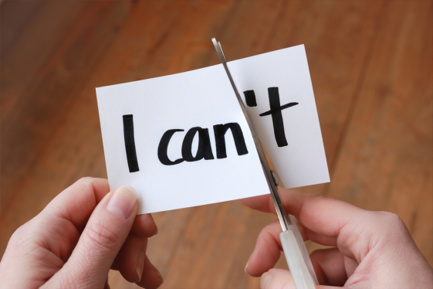
Skillful Thoughts

Self-talk with more thought
Wisdom is your ability to imagine

alternatives and judge their likely

outcomes. Just choose to be wise

and you’ll make better decisions;

keep at it and you’ll become wise.

Weather your thoughts are right or wrong, helpful or hurtful, they become your reality. Your explanations lead you toward the outcomes you put into them. The common thoughts below that are (underlined) tell you that you can’t. The same thoughts (with the dots) tell you CAN, empower you, keep your life on course and LEAD you toward better outcomes.

Better thoughts come from trying to:
- use accurate facts and the proper emotions for each thought.
- consider carefully the interest and feelings of all others involved
- consider the likely consequences of each alternative
- include the absolute truth about your motivation and capabilities
- note your responsibility, if any, for creating the existing conditions
- note the direction you want this matter to have on your life
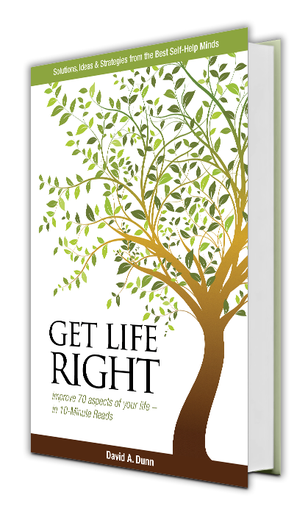
.
Download Skillful Thoughts free Click on the Series letter or FS

Series

A – Sharpen Your Thinking

B – Plan a Really Exciting Life

C – Get the Most out of Your Attributes

D – Finance the Life You Want

E – Attract People You’d Like to be Like

F – Improve Your Relationships & Marriage

G – Create a Close Family

H – The Best Life You can Have

FS – Full Set

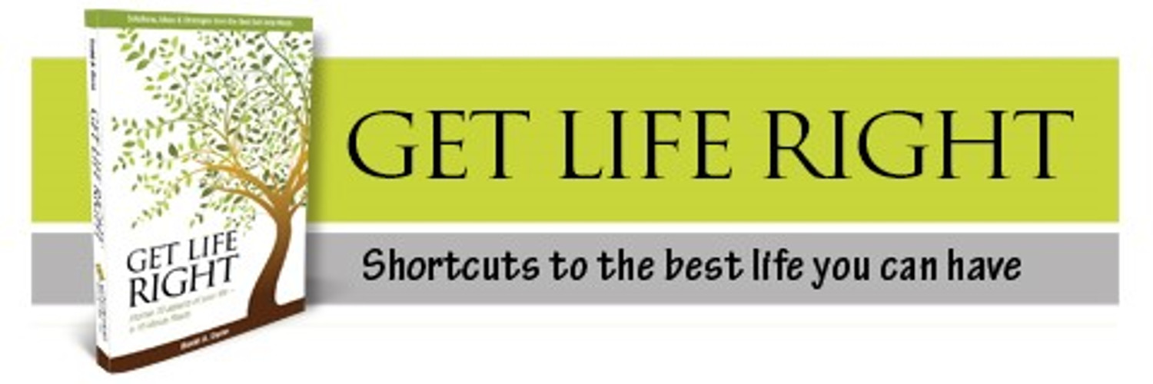

Skillful Thoughts

Series H – The Best Life You Can Have

Underlined thoughts diminish you - Thoughts with dots empower you

H-1 Use Your Full Potential
This is my potential. I’ve used my best thinking to get me here.
- With less effort I could have accomplished a lot more if I had better ideas.
- With better thinking, the future I am headed for can be much bigger and better.
Just surviving takes all of my energy.
- I can accomplish more with my mind than I can with body. To make that happen, I am reading Get Life Right.
- Instead of resisting change I am going to chase it.
I’ll worry about my potential once I can pay my bills.
- I will make improving my judgment and ability to think more of a priority
- I will develop my creativity to speed up my growth in these areas.
- Instead of looking down on the assembly line where the things of my life are passing before me, I will look up to see if I like where the assembly line is going, and look around for one with better ingredients or going to a better place.

H-2 Make all Your Time Precious
Why live if you can’t listen to music or watch sports.
- My time is an asset, and I have decided to make the best use of it that I can.
- Unless I become a disc jockey, sportscaster or coach, the time I spend with them gives me only entertainment, but no lasting benefit.
- I’ll spend my time on activities that will give me more to show for my time.

H-3 Enhance Your Life with a Purpose

I feel bogged down in busy work and I’m not going anywhere.
- A purpose would make me happier about myself and help me prioritize my time.
- Now that my last child is leaving home it’s time for me to choose a new purpose.
I have to save every cent for retirement; I can’t afford a purpose.
- A purpose is more about how I am as a person and how I spend my time than how much money I can give.
- Being a good friend and mentor is a good purpose.
- How can I get the best return on my time and talents in service to others?
- Most purposes involve working with people who have like interests and values; it will be a good way to meet some like-minded new friends.

The Best Tip
I get all of the above but I am still lonesome, scared and unsure of myself; how do I make those go away?
Socialization is the most essential ingredient for a longer and happier life so I’m going to make that my top priority.
I am going to start by improving my relationship with the power greater than me. What could be better than to have my Creator to guide me, keep me company and quieting my anxieties?
Your creator is still taking applications. He has no entrance exam, no dues and fabulous retirement program. Get acquainted or get closer and stay close. You couldn’t ask for a better companion!

